

**DECENTRALIZED**

AI-Assisted

Peer-to-Peer

Messaging Protocol

Using Fractal Propagation

with

**LOW** Footprint

&

Complete Privacy

**MAMAWMAIL**: Serverless. Uncensored Decentralized Global SWARM Communication System

# Updated Whitepaper — September 1, 2025 (Original June 20, 2025) engr juan carlos ayeng, bacolod city, the philippnes

I.F.P.P. IMPLEMENTATION

**ONGOING/UNFINISHED**

1. Abstract

**MAMAWMAIL** introduces a decentralized, serverless communication system designed to overcome the limitations of traditional email and messaging infrastructures.

Built on the **Intelligent Fractal Propagation Protocol** (IFPP), it:

* + - eliminates central points of failure and
    - enables resilient, self-sustaining delivery across dynamic peer-to-peer networks.

Unlike conventional systems where packets act as passive couriers along rigid routes, MAMAWMAIL packets behave like autonomous convoys, each guided by an internal “Angelic Army: **Scout Ranger team**” that scouts, defends, communicates, and decides the next hop.

Devices act as intersections in a vast traffic grid: they provide signals and local rules, but the ultimate decision lies with each packet’s **internal team.**

*This ensures that routing is* ***dynamic*** *and* ***device-agnostic****,* ***offloading intelligence from infrastructure into the packet itself****.*

Oversight is provided by a consensus mechanism embodied in “**Archangel Gabriel Signals**,” which:

* + - independently confirm handoffs,
    - record path digests, and
    - distribute immutable histories that form the shared memory of the swarm.

By embedding IFPP into a functional application, MAMAWMAIL demonstrates how communication can persist without reliance on cloud servers, ISPs, or centralized authorities.

The system defines a new architectural model consisting of seven interoperable layers:

1. Message Architecture;
2. Propagation Architecture;
3. Crawler Architecture;
4. Intelligence Layer Architecture;
5. Self-Healing/Self Pruning Architecture;
6. Singularity Architecture;
7. Privacy Architecture.

This abstract framework is validated through a concrete implementation, showcasing the feasibility of resilient peer-based messaging while maintaining cryptographic security, adaptive scalability, and verifiable delivery.

MAMAWMAIL is not only a working communication platform but also a **research testbed for packet-level intelligence**, **swarm consensus**, and **digital guerrilla networking**—expanding the frontier of decentralized communication.

1.0 Introduction

The current Internet is built on the TCP/IP protocol stack, which was revolutionary in its time but is fundamentally limited for the challenges of today. TCP/IP was designed in an era where networks were fragile, nodes were scarce, and “best effort” was sufficient. Its assumptions are now outdated:

* **TCP/IP today**: a smart router, dumb network model. Packets are dumb envelopes, blindly hopping across nodes until they expire. Reliability is patched on top with retransmissions and timers. Packets vanish silently (TTL), routes are unknown, and interception or sniffing is trivial. Sending a packet is like sending a cowboy into the wild west — once it leaves, anything might happen. There are no marked highways, no road signs, no memory of the journey.
  + **Dumb packets**. They blindly hop until TTL expiry.
  + **Opaque routing.** Senders cannot see or verify a packet’s journey.
  + **Infrastructure dependency**. Reliability depends on routers and centralized servers.
* **MAMAWMAIL** tomorrow: a device-centric, intelligent communication system. At its core lies the Intelligent Fractal Propagation Protocol (IFPP), a protocol that makes packets self-guiding couriers with memory, decision-making, and persistence. They do not expire but continue until delivery is achieved. The network itself becomes intelligent: headers and decision states guide routing at every hop.
  + MAMAWMAIL rethinks communication by embedding IFPP directly into a working system:
    - **Packets with intelligence.** Each carries memory and decision-making, persisting until delivery.
    - **Device-centric, not infrastructure-centric**. Nodes are peers, not dependent on centralized servers.
    - **Swarm-guided propagation**. Consensus and Gabriel signals enforce verifiable, collective delivery.

Crucially, MAMAWMAIL is not a start-from-scratch reinvention, but an evolution made possible by today’s unprecedented global interconnectivity. It proposes a fundamental shift in how we think about communication: from client–server dependency and dumb packet transport to intelligent, self-pruning, swarm-based propagation.

Key Innovation: MAMAWMAIL is the first implementation of IFPP, showcasing its practical use as a decentralized communication system. While IFPP can stand on its own as a protocol, MAMAWMAIL demonstrates how its innovations can be harnessed in real-world software and architectures.

*MAMAWMAIL demonstrates that IFPP’s principles are practical, scalable, and secure—ushering in a new model of communication: intelligent, persistent, and swarm-driven.*

2.0 Conceptual Foundations

# To understand the need for MAMAWMAIL and the protocol that powers it (IFPP), it is important to clearly contrast the limitations of TCP/IP with the innovations introduced here. This section provides evaluators with a clear conceptual springboard.

## 2.1 **TCP/IP Today**: Smart Routers, Dumb Networks

TCP/IP was designed for fragile early networks. Packets are dumb envelopes, blindly hopping until they expire (TTL).

Routes are unknown, interception is easy, and reliability is patched over retransmissions.

Sending a packet is like sending a cowboy into the Wild West: once it leaves, anything can happen. No highways, no road signs, no memory of the journey.

## 2.2 **IFPP Tomorrow**: Intelligence in the Network

MAMAWMAIL **implement**s IFPP, a protocol that turns packets into self-guiding couriers. Headers and routing metadata enable decision-making at every hop. Packets never expire — they persist until delivery — embodying **Sacred Persistence**.

## 2.3 **Not Reinventing** the Wheel

IFPP is not a **start-from-scratch reinvention**. It is made possible by today’s unprecedented level of global interconnectivity. MAMAWMAIL demonstrates how IFPP can operate in practice as a decentralized messaging system.

## 2.4 From **Frontier Chaos** to **Structured Intelligence**

TCP/IP Frontier:

1. Packets Expire (TTL),
2. Paths Unknown,
3. Traffic Easily Sniffed Or Hijacked.
4. A Dark Wilderness.

MAMAWMAIL Paradigm:

1. *Device-Centric,*
2. *Intelligent Propagation.*
3. *Messages Survive,*
4. *Routes Are Remembered, And*
5. *The Swarm Itself Learns.*

## 2.5 **Innovations** Demonstrated in MAMAWMAIL

* **DEVICE-CENTRIC ANONYMITY**: the device, not the user, is the network identity.
* **TOTAL MODULARIZATION & ENCRYPTION**: payloads are encrypted end-to-end; only the destination device can decrypt.
* Three-Module Payload Structure:

1. Module A: **ROUTING DIGEST**
2. Module B: **INTEGRITY & AUTHENTICATION**
3. Module C: **PAYLOAD FRAGMENT**
4. Two are retained as “road markers” while the third moves forward.

* **ANGELIC ARMY** (Crawlers/Scouts): lightweight scouts explore candidate devices and paths in advance, lighting and guiding the way for the message packet.
* **ARCHANGEL GABRIEL SIGNALS**:

1. **SUCCESSFUL HANDOFF SIGNAL**: confirms safe relay payload copy/transfer, triggering deletion of the old copy in previous device.
2. **DELIVERY SUCCESS SIGNAL**: flows back to sender with a digest of the successful path. This is the TRUMPET SIGNAL/TRIUMPHANT SIGNAL;

* **SACRED PERSISTENCE**: messages DO NOT EXPIRE until delivered.
* **HORIZONTAL SINGULARITY**: at scale, routes saturate until delivery is nearly guaranteed.
* **VERTICAL SINGULARITY**: the system learns the minimum number of message copies required for assured delivery.
* **FRACTAL HOP** vs. **SINGULAR HOP**: adaptive redundancy balances reachability and efficiency.

MAMAWMAIL thus embodies a fundamental shift in networking: not incremental improvement, but a rethinking of the entire model.

## 2.6 IFPP: DEFINING ITS **COMPONENTS**

### At the heart of MAMAWMAIL is IFPP — the Intelligent Fractal Propagation Protocol. It can be understood by breaking down its four pillars:

**A. INTELLIGENT**  
Moves beyond “smart routers, dumb networks.” IFPP equips packets with multi-header metadata enabling routing and decision-making inside the network itself. No central monolithic server dictates paths. As packets travel, old copies are pruned, successful handoffs are confirmed, and a backward success signal maps the route. Payloads remain encrypted, visible only to the destination device.

**B. FRACTAL**  
The Angelic Army dynamically decides between fractal hops (replication to multiple candidates) and singular hops (one precise path) depending on network conditions. This adaptability balances efficiency and resilience, ensuring network stability even under stress.

**C. PROPAGATION**  
Propagation resembles biological growth patterns — bacteria multiplying, leaves unfurling — yet remains intelligent. Packets erase old copies, track “where they’ve been,” and learn from successes. Successful routes are stored and shared across the swarm. Over time, this produces global order out of local interactions, converging toward Horizontal and Vertical Singularities.

**D. PROTOCOL**  
IFPP is not a single implementation but a replicable convention. Architectures can diverge and evolve independently. Enterprise deployments may pre-map internal paths for speed, while community editions benefit from open swarm learning. Payloads themselves are modular and extensible, able to carry more complex content and metadata in future evolutions.

3.0 Glossary of Terms

# Building the Shared Mental Model of IFPP

This section provides precise definitions of core terms and symbolic references used throughout IFPP and MAMAWMAIL. It serves two purposes:

To prevent misinterpretation by aligning readers to a common vocabulary.

To act as a conceptual springboard for the more technical sections that follow, such as architectures, propagation mathematics, and protocol comparisons.

Because IFPP introduces novel constructs that differ from conventional networking terminology (e.g., multicast, persistence, hop semantics), this glossary ensures evaluators approach the system with a coherent and unified frame of reference.

**MAMAWMAIL**

A decentralized, messaging system that is the first implementation of IFPP. It is deigned to be the primary implementation of IFPP.

**IFPP (INTELLIGENT FRACTAL PROPAGATION PROTOCOL)**

The foundational protocol behind Mamawmail’s initial implementation. Manages propagation, persistence, and delivery without central servers.

**ETERNAL MESSAGE CORE**

The encrypted, immutable payload carried through Mamawmail. Only the destination device can decrypt it.

**BEEN-HERE FLAG**

Device-level safeguard to prevent looping or redundant hops.

**ANGELIC ARMY**

The guiding swarm of crawlers and relays ensuring messages move safely through the decentralized network.

**ARCHANGEL GABRIEL**

Metaphorical herald of successful delivery. Represents Mamawmail’s built-in reliability guarantee.

**SACRED PERSISTENCE**

Mamawmail’s principle that messages never expire prematurely; persistence is guaranteed until success is confirmed.

**MULTICASTING (PSEUDO-SESSION)**

Two-way communication flow between devices, enabled by IFPP, but abstracted for application-level reliability in Mamawmail.

**SEVEN ARCHITECTURES OF MAMAWMAIL**

The modular sub-architectures powering Mamawmail: orchestration, message architecture, propagation, crawler, device sync, monitoring, and frontend integration.

1. Message Architecture;
2. Propagation Architecture;
3. Crawler Architecture;
4. Intelligence Layer Architecture;
5. Self-Healing/Self Pruning Architecture;
6. Singularity Architecture;
7. Privacy Architecture.

**ENTERPRISE EDITION**

Mamawmail deployment designed for large organizations with additional tooling for governance, compliance, and high performance.

**COMMUNITY EDITION**

The open, grassroots edition of Mamawmail, encouraging broad adoption and community-driven development.

SINGULARITY EVENT

In the context of MAMAWMAIL and IFPP, a Singularity Event refers to a mathematical convergence point describing network behavior. Two dimensions are defined:

1. HORIZONTAL SINGULARITY – The equation describing the number of possible message paths in a mesh. As more paths are discovered and optimized, overall delivery latency approaches zero, similar to the way an integral equation approaches a limit.
2. VERTICAL SINGULARITY – The equation describing the redundancy required for reliability. It measures how many duplicate messages are necessary to ensure that delivery probability approaches certainty.

Together, these singularities represent the system’s mathematical boundaries for efficiency and reliability, and they provide the predictive targets for the AI layer to optimize.

4.0 implementation

# The MAMAWMAIL system is realized through

# **seven architectural layers**.

# The Intelligent Fractal Propagation Protocol (IFPP) is the unifying mechanism that brings these architectures to life. Together, they form a self-organizing, privacy-preserving, and delivery-assured messaging system.

## 4.1. **Message** Architecture

The message is structured in three modular parts:

1. **EPHEMERAL HEADERS** – transient routing and device-specific instructions.
2. **PATH / AI METADATA** – digest of routing history, learning context, and swarm intelligence data.
3. **PAYLOAD** – the eternal message core, the only part preserved from hop to hop.

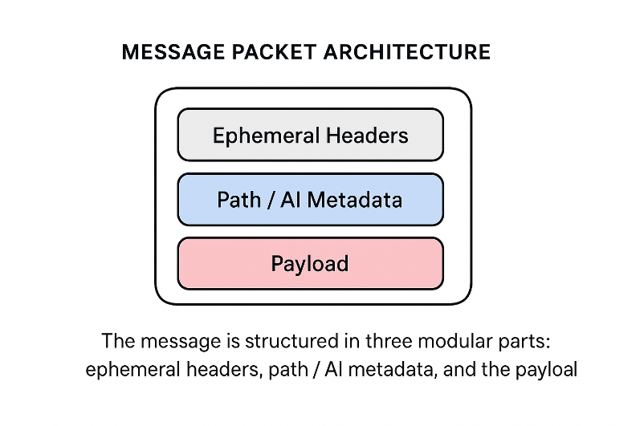

This modular separation ensures that learning and routing evolve while the payload remains intact.

Messages are structured with a permanent encrypted core (“**ETERNAL MESSAGE CORE**”) surrounded by mutable headers.

IFPP embeds handoff rules and been-here flags into these headers, ensuring controlled propagation and deletion.

## 4.2. **Propagation** Architecture

The HEART of IFPP.

Message packets spread in a fractal expansion up to a defined depth, ensuring redundancy.

1. **FRACTAL HOPS** – for exploration, redundancy, and ensuring robustness.
2. **SINGULAR HOPS** – for efficiency, once a known path has been validated.

A balance between exploration (fractal) and exploitation (singular) is achieved by federated learning **across the swarm**.

After a threshold, IFPP collapses the expansion into singular optimal paths, avoiding network flooding.

**Handoff deletion** ensures only one live payload exists per path.

## 4.3. **Crawler** Architecture (The **Angelic Army**)

A distributed “Angelic Army” of crawlers constantly discovers candidate devices and maps local neighborhoods.

IFPP consumes crawler data to decide whether to spread **FRACTALLY** or pivot to **SINGULAR** delivery.

The crawler is the GUIDING ENTITY of the system, responsible for

1. **DEVICE DISCOVERY** and
2. **CANDIDATE PATH EVALUATION**.

Operates first on IP discovery, but can fall back to Bluetooth radio or UDP hole punching in constrained networks.

The crawler checks each device it enters, comparing the path digest with the candidate next device.

The crawler is the angelic army — searching continuously for new paths and opportunities, never resting, always probing the network.

## 4.4. **Intelligence** Layer (Swarm Memory)

Hosts the adaptive decision-making engine of IFPP.

The intelligence layer stores success and failure digests of paths — but **never the payload itself.**

Successful routes are **REINFORCED** and **SHARED** across the swarm.

Failed routes decay from memory, preventing wasted retries.

This **distributed intelligence** allows the swarm to become stronger with every attempt.

This is the **shared mind of the angels**, remembering the safe paths while forgetting the broken ones.

Learns from network outcomes, adjusting propagation thresholds dynamically.

Provides **TUNABLE RUNTIME PARAMETERS** (max hop depth, fractal-to-singular ratio).

## 4.5. **Self-Healing** | **Self-Pruning** Architecture (Archangel Gabriel)

Every successful handoff triggers deletion of the transient message copy on the sending device. Only the receiving device now holds the living payload, the **ETERNAL MESSAGE CORE**.

This prevents uncontrolled replication and saves resources.

Successful deliveries trigger reverse signals that prune redundant paths.

If a path fails, new paths are sought dynamically until a success is achieved.

When a full path is confirmed, a **return signal carries the success digest back** through the swarm.

This architecture is known as the “**ARCHANGEL GABRIEL”** within the system— the custodian of truth, bringing back the successful path to the sender and broadcasting it to the angelic armies, so that the swarm/army remembers.

IFPP integrates directly here by **embedding confirmation digests** into return signals.

## 4.6. **Singularity** Architecture (Chaos Attractor Goals)

At the macro level, IFPP ensures propagation **converges to stable attractors**: a minimal, efficient backbone.

The swarm as a whole strives toward two singularities, modeled with chaos attractor mathematics:

1. **HORIZONTAL SINGULARITY** – [PATH SATURATION]

Models path optimization. It is the limit equation describing the number of discovered and active routes required such that effective message latency approaches zero.

This represents the optimization problem of pathway identification in a device mesh.

The system learns how many distinct paths are required between a sender and a recipient to reduce latency toward zero.

Formally, the singularity is the limit function describing the number of paths 𝑃 needed such that as 𝑃 increases, average delivery latency approaches zero:

where 𝑃∗ is the saturation point of identified viable paths, and 𝐿(𝑃) is expected latency.

Machine learning dynamically approximates 𝑃∗, adjusting as network topology evolves.

1. **VERTICAL SINGULARITY** – [MESSAGE UNIT SATURATION]

Message Packet Unite redundancy optimization. It is the limit equation describing the number of message replications required such that delivery reliability approaches one.

This represents the optimization problem of redundancy and reliability.

The system learns how many messages or replicas are required to maximize delivery assurance without unnecessary overhead.

Formally, the singularity is the limit function describing the number of messages 𝑀 such that as 𝑀 increases, delivery probability approaches one:

where 𝑀∗ is the saturation point of replication, and 𝑅(𝑀) is reliability probability.

Machine learning continuously searches for 𝑀∗, balancing reliability with efficiency.

The singularities are the strange attractors — the ultimate destination of the fractal, the macro-level goals the swarm approaches.

Instead of hardcoded rules, ***MAMAWMAIL uses singularity equations as optimization targets***.

## 4.7. **Privacy** Architecture

Privacy is preserved through end-to-end cryptography built into every payload. End-to-end encryption is enforced at the message core.

The **ETERNAL MESSAGE CORE** is encrypted at the source and can only be decrypted by the destination device using its unique cryptographic hash.

Payloads are opaque to crawlers and AI layers; they cannot be read or altered during transit.

Because headers and digests are sufficient for routing and scoring, payloads remain ephemeral in transit — existing only as encrypted fragments until successful delivery.

This ensures absolute confidentiality: even as the angelic armies carry the swarm forward and Archangel Gabriel confirms delivery, only the intended recipient may ever read the message.

IFPP deletion rules prevent duplicated payloads from being exploited.

5.0 message architecture

# The MAMAWMAIL Message Architecture defines how every message is created, guarded, propagated, and persisted within the swarm.

# Whereas traditional Internet packets are inert and disposable, MAMAWMAIL messages are living tactical units: they carry within them both encrypted payloads and embedded guardianship logic.

# A message in MAMAWMAIL is not just data in motion. It is a persistent digital entity, escorted by agents, guided by memory, and protected by safeguards until delivery is achieved under the doctrine of Sacred Persistence.

## 5.1. **CORE PRINCIPLE**

At the heart of IFPP and MAMAWMAIL is the idea that a message is not a disposable packet but a self-guarding unit with its own escort microarchitecture. Every device in the swarm holds dormant templates of these escorts, which are awakened when a message arrives.

Together, they preserve the Eternal Message Core and ensure safe delivery under the doctrine of Sacred Persistence. This design ensures that delivery is not left to chance: custody is continuous, authority is clear, and persistence is absolute.

## 5.1.1 **Eternal Message Core**

The Eternal Message Core is the unalterable payload. It is encrypted, immortal, and persists until delivery. It carries:

1. **The message payload.**
2. **Angelic shards that activate escort agents in each device.**
3. **A binding identity ensuring continuity across hops.**

The Eternal Core contains:

* *The actual message payload.*
* *Angelic shards that activate escort agents on each device.*
* *Binding continuity markers that link each hop to Gabriel’s global ledger.*

The Eternal Message Core (EMC) is the immutable payload container:

* *Encrypted using AES-256-GCM.*
* *Immortal — never deleted until Gabriel validates delivery.*
* *Sharded — contains Angelic activation fragments that spawn escorts per hop.*
* *Bound — identified by a unique MessageID to ensure continuity.*

Pseudocode: EMC Custody

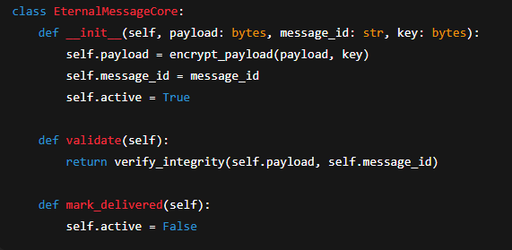

**FIGURE 5.1**

*Each device ensures the EMC is never destroyed prematurely. Only Gabriel’s Trumpet can trigger* ***mark_delivered().***

## 5.1.2 **Message Components**

The message is composed of three main parts:

1. **Ephemeral Headers**
   1. Carry routing metadata.
   2. Contain been-here flags and deletion instructions.
   3. Adapt dynamically with each hop.
2. **AI Metadata**
   1. Encodes adaptive heuristics for swarm routing.
   2. Contains device-neighbor scoring, path learning, and swarm-level memory digests.
   3. Helps the escort team decide efficient next hops.
   4. Contributes to Gabriel’s federated digest.
3. **Payload** (**Eternal Message Core**)
   1. The immortal, encrypted data to be delivered.
   2. Custodied by the last man agent.
   3. Surrounded by the angelic army, ensuring it cannot be lost.
   4. Encrypted using AES-256-GCM.

It is **within this payload that the angelic army is instantiated** — the tactical guardian unit that defends and directs the eternal message core.

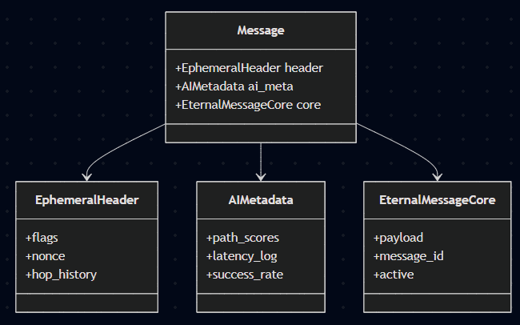

**FIGURE 5.2**

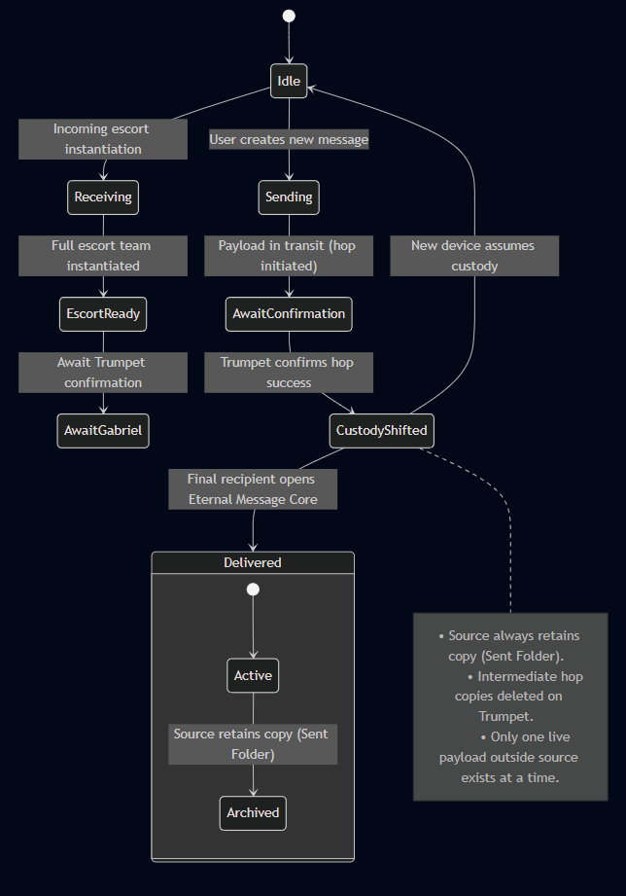

**FIGURE 5.3-***Finite State Machine of IFPP custody logic.*

*Each hop creates a temporary escort and payload instance on the new device. Once Gabriel confirms with the Trumpet signal, the old hop instance is deleted. The source device always retains an archival copy (like a “Sent Folder”), but only one active external custody exists at any time until final delivery.*



SOURCE DEVICE

INTERMEDIATE DEVICE 2

FINAL DEVICE

INTERMEDIATE DEVICE 1

**IFPP Can use:**

* **WIFI [Raw Frames],**
* **TCP/IP,**
* **UDP Punching,**
* **BLUETOOTH**







ESCORT INSTANTIATES





ESCORT INSTANTIATES

PAYLOAD CUSTODY

Message Created

Archive in SENT Folder

PAYLOAD CUSTODY

COPY DELETED

ESCORT INSTANTIATES

PAYLOAD CUSTODY

HOP 1 METADATA LOGGED

COPY DELETED

TRACEBACK Consolidation

HOP 2 METADATA LOGGED

FINAL DELIVERY

RETURN TRACEBACK RELAY

RETURN TRACEBACK INITIATED

RETURN TRACEBACK RELAY

GABRIEL OVERSIGHT

Trumpet Confirmation

TRACEBACK AGGREGATION

**FIGURE 5.4**

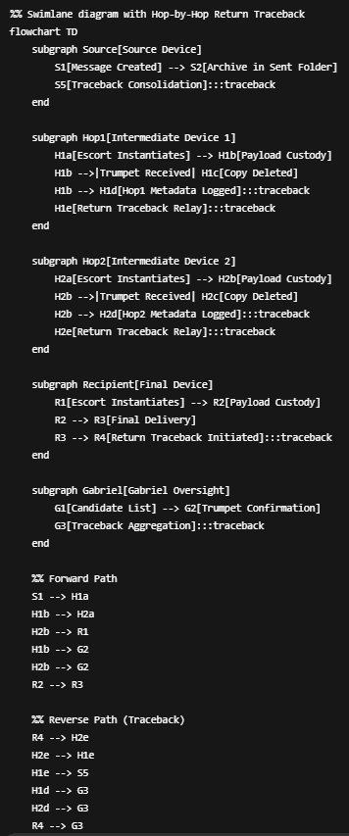

**FIGURE 5.4, 5.5, 5.6**

*Swimlane diagram of IFPP custody flow with Return Traceback.*

*The Source device always archives a permanent copy. Intermediate devices temporarily hold custody and log hop-level metadata, which flows back as part of the Return Traceback.*

*The Recipient generates a final success digest and returns it to Gabriel.*

*Gabriel aggregates all metadata into a swarm-wide ledger, then sends a consolidated digest back to the Source device.*

*This ensures swarm learning, validates successful paths, and maintains delivery provenance.*

**Hop-by-hop Return Traceback in IFPP.**

Once the Recipient delivers the payload, it initiates a reverse journey where the traceback packet passes sequentially back through each device in the successful forward path.

Each hop appends AI metadata (latencies, retries, been-here flags, candidate scoring). Gabriel aggregates this swarm knowledge, while the Source archives a final consolidated digest alongside the “Sent” copy.

This guarantees end-to-end provenance and swarm learning — something absent in TCP/IP acknowledgments.

**FIGURE 5.5**

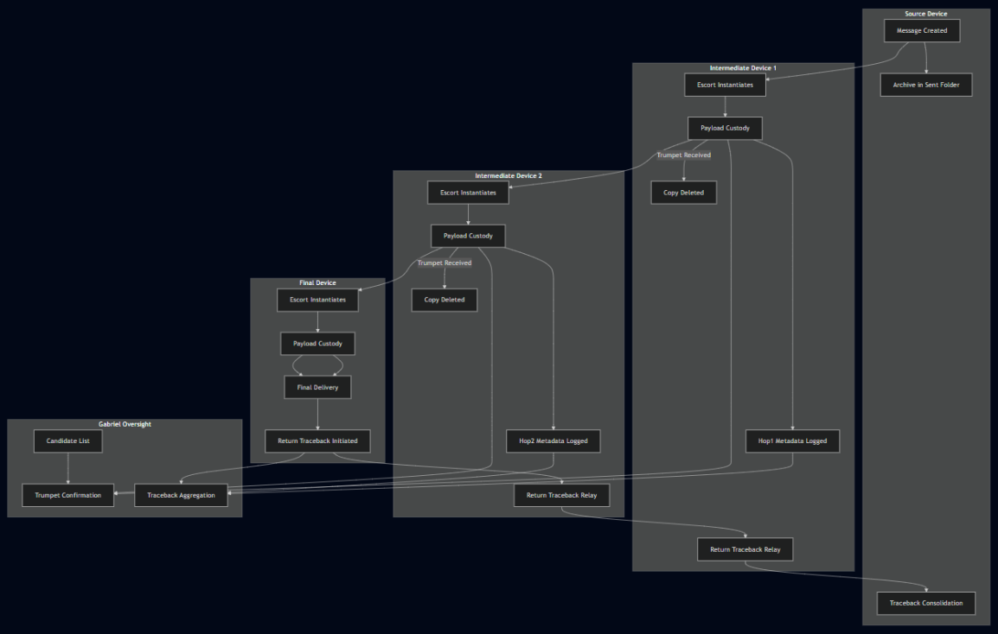

**FIGURE 5.6**

## 5.2 The **Philippine Scout Ranger** Analogy

The **MESSAGE ARCHITECTURE** draws inspiration from the tactical doctrine of the Philippine Scout Rangers, renowned for small-unit guerilla warfare. IFPP “…in honor of the Philippine Scout Rangers, whose 7-man rifle teams inspired this microarchitecture…”

A typical older-version 7-man Scout Ranger team includes:

1. **SCOUT** – advances to locate threats and paths.
2. **POINT MAN** – first in contact, stabilizes engagements.
3. **LEADER/OFFICER** – makes tactical decisions.
4. **HEAVY WEAPONS MAN** – provides supporting firepower.
5. **INTEL/RADIO MAN** – maintains situational awareness and communication.
6. **LIAISON** – connects with external allies.
7. **LAST MAN** – secures the rear and ensures no loss of unit integrity.

“The IFPP operates according to principles of small-unit tactics — autonomous maneuver, adaptive pathfinding, and self-defense at every step. Like a guerilla team, it analyzes its environment, decides its route dynamically, and ensures survival until the objective is secured.

**In honor of the Philippine Scout Rangers**, whose 7-man rifle teams embody these tactics, this microarchitecture is modeled as a living escort unit for each message.”

“Scout Rangers complete the mission under any condition.

So too do MAMAWMAIL messages — they cannot expire, they cannot be abandoned, **they persist until arrival**.”

## 5.3 **Angelic Guardians** and **Guides** (Message Equivalent)

Each message instantiates an Angelic Army, a 7-agent escort team, directly mapped from the Scout Ranger doctrine. These guardians embody specialized functions:

* They scout, validate, replicate, log, and coordinate.
* They operate autonomously yet cohesively.
* They dissolve and re-form with each hop, carrying forward their mission context.

Thus, every message is not just a packet but a living tactical unit, reborn at each step of its journey.

## 5.4 The Seven **Angels**

At the heart of MAMAWMAIL’s doctrine is the Seven Angels, the living escort team that embodies packet-level guardianship. Unlike IFPP’s more generalized tactical framing, MAMAWMAIL fixes the Seven Angels into formalized protocol roles that govern custody, authority, and swarm interaction at every hop.

Each angel is modular, independently updateable, and instantiated anew at every device. Together, they dissolve and reform across hops, ensuring the Eternal Message Core remains secure, unbroken, and immortal until final delivery.

Angel Roles and Functions

1. **RECON** — Passive Scout
   1. Instantiates to candidate devices (as identified by Intel and Gabriel).
   2. Verifies been-here flags, local logs, and neighbor consistency.
   3. Operates strictly under Leader’s orders.
   4. Reports findings back without initiating transfers.
2. **POINT** — Payload Escort & Decoy
   1. First into every hop environment.
   2. Validates safety of the new device, absorbing errors or malicious probes.
   3. Never leaves the Eternal Message Core unguarded.
   4. Ensures transfer is initiated only if environment integrity is verified.
3. **LEADER** — Commander & Decision-Maker
   1. Central authority within the escort team.
   2. Aggregates Recon reports, Liaison data, and Intel’s candidate lists.
   3. Selects next hop and issues orders to the escort unit.
   4. Note: Leader never speaks to Gabriel directly — delegation is enforced.
4. **INTEL** — System Link to Gabriel
   1. One of only two angels (with Last Man) authorized to communicate with Archangel Gabriel.
   2. Requests updated device lists.
   3. Forwards Gabriel’s global view to Leader for tactical decision-making.
   4. Functions as the swarm’s “radio man” inside the escort unit.
5. **HEAVY WEAPONS** — Security Specialist
   1. Deploys updated security sweeps before payload entry.
   2. Neutralizes risks flagged during reconnaissance or payload transfer.
   3. Modular, updateable independently of other angels for adaptive security.
6. **LIAISON** — Device Communicator & Knowledge Broker
   1. Talks directly with the current host device.
   2. Collects logs, resource metrics, routing intelligence.
   3. Shares swarm-approved intelligence back to the device.
   4. Acts as the “civilian-military liaison,” strengthening nodes without exposing payload.
7. **LAST MAN** — Custodian of the Eternal Message Core
   1. Sole bearer of the payload.
   2. Waits for Gabriel’s Trumpet before deletion of the old copy.
   3. Guarantees that at any given time only one complete live copy of the Eternal Core exists outside the source device.
   4. Anchors the doctrine of Sacred Persistence.

## 5.4.1 **MAMAWMAIL INSTANTIATION** – Angelic Army

Each Mamawmail message spawns an Angelic Army of seven modular agents. These are microservices inside the Mamawmail Engine:

* They are awakened from dormant templates.
* They operate autonomously but follow Leader-issued orders.
* They dissolve and re-instantiate at every hop.

ESCORT INSTANTIATION PSEUDOCODE:

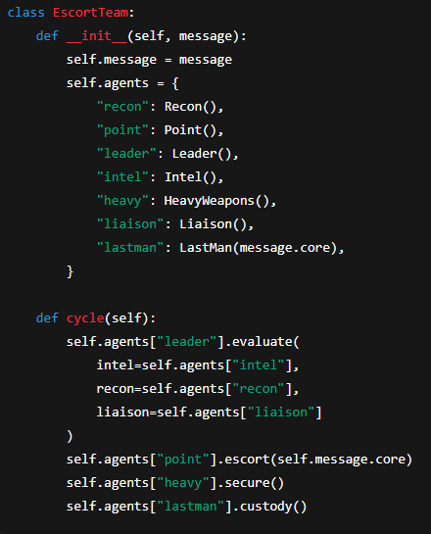

## 5.5 **Archangel Gabriel** (System-Wide Messenger)

GABRIEL exists outside the message, omnipresent across the swarm. Gabriel is not part of any single message, but a swarm-wide, omnipresent authority that validates truth, prevents deception, and witnesses every transition.

RESPONSIBILITIES OF GABRIEL:

1. Aggregates candidate device lists continuously.
2. Confirms successful handoffs and signals the Trumpet to the Last Man.
3. Deletes redundant copies at intermediate hops once validation succeeds.
4. Detects false paths, incomplete handoffs, or message tampering attempts.
5. Consolidates metadata into swarm memory for long-term adaptive routing.

COMMUNICATION DISCIPLINE:

1. Only Intel and Last Man are authorized to speak to Gabriel.
2. This strict rule prevents spoofing and ensures command integrity.
3. Gabriel never overrides Leader’s tactical decision, but validates its outcomes.

Gabriel thus functions as truth-bearer and validator, enabling the escort unit to fight and maneuver while ensuring every hop remains authenticated and immortal.

Gabriel ensures that the system cannot be deceived by false hops or partial transfers — delivery is always authenticated. Gabriel is the **SWARM-WIDE** **ARBITER** and **MESSENGER**.

## 5.6 **Singularity** and Guerilla Model of Propagation

The swarm operates like a guerilla unit, agile and adaptive, compared to the rigid infrastructure of centralized servers and blind IP packets.

* Internet Today: rigid central servers, blind packets without memory, time-limited TTL expiry.
* MAMAWMAIL: tactical packets with memory, AI heuristics, and escort autonomy.
* Singularity Principle: after sufficient propagation, the swarm converges into singular direct hops, conserving resources while preserving delivery certainty.

**This mirrors the small-unit guerilla doctrine: agile, light, adaptive, resilient, small units vs. massive rigid formations.**

## 5.7 **Sacred Persistence**

MAMAWMAIL overturns the philosophy of modern networking. Instead of time-limited packets (TTL) that can expire, Sacred Persistence ensures immortality of delivery:

1. Messages never expire.
2. Custody is continuous from creation until final delivery.
3. Deletion occurs only after Gabriel’s Trumpet confirms safe handoff.
4. Source device always retains a record copy (Sent Folder equivalent).
5. Every intermediate hop deletes its copy immediately after successful transfer — ensuring only one full copy exists outside the source at any time.

This guarantees that even if the swarm is partitioned, disrupted, or under attack, the Eternal Message Core cannot be lost or corrupted.

## 5.8 **Summary**

Key Takeaways:

* A message is not inert — it is a living architecture.
* Seven Angels = tactical escort unit derived from Scout Ranger doctrine.
* Gabriel = independent messenger and validator.
* Sacred Persistence replaces TTL — messages never die.
* Guerilla-style swarm propagation replaces rigid centralized routing.
* This architecture ensures absolute delivery assurance, making IFPP/MAMAWMAIL fundamentally distinct from TCP/IP.

*This makes MAMAWMAIL fundamentally distinct from TCP/IP: where* ***TCP/IP is probabilistic and expiring****,* ***MAMAWMAIL is persistent, adaptive, and immortal****.*

6.0 application of ifpp in mamawmail

# The Intelligent Fractal Propagation Protocol (IFPP) is not presented as a theoretical construct alone, but as the living transport fabric of MAMAWMAIL.

# While Section 6 of the IFPP whitepaper established the propagation logic and formal models, here we translate those foundations into their role within the MAMAWMAIL ecosystem.

At the system level, MAMAWMAIL treats IFPP as both a native transport and a selective encapsulation layer. This duality provides the user and the system designer with a choice: either rely on IFPP’s self-sufficient fractal propagation, or tunnel IFPP payloads through existing TCP/IP-OSI infrastructure for compatibility and hybrid deployments.

## 6.1 **Application Structure**

MAMAWMAIL’s application stack integrates IFPP as a core relay module, ensuring that propagation, custody, and pruning are natively handled without reliance on centralized servers. The application stack is organized as follows:

1. **FRONTEND (MOBILE / DESKTOP APP)** – User interface for composing, sending, receiving, and managing messages. Provides delivery confirmations, custody logs, and mode selection (native IFPP or hybrid encapsulation).
2. **SEVEN ARCHITECTURES (WITH IFPP CORE)** – The heart of MAMAWMAIL. Each architecture interacts with IFPP’s Seven-Agent Microarchitecture, executing custody transfer, redundancy control, hop management, and privacy enforcement:
3. **MESSAGE ARCHITECTURE**
   * Messages are modular in three parts:
     1. **EPHEMERAL HEADERS** – transient custody tokens, been-here flags.
     2. **PATH / AI METADATA** – handoff confirmations, route scoring data.
     3. **PAYLOAD** – encrypted Eternal Message Core.
   * IFPP keeps headers and metadata mutable in transit, while the payload remains untouched and destination-bound.
4. **PROPAGATION ARCHITECTURE**

* Messages spread in a fractal pattern, expanding across multiple peers before converging into singular paths.
* Federated learning dynamically determines when to use wide fractal hops or optimized single-hop propagation.

1. **CRAWLER ARCHITECTURE**

* Establishes device-to-device contact using IP as a baseline.
* Falls back to Bluetooth radio or UDP hole punching for firewall-penetration and ad-hoc connectivity.
* Guided by Recon and Point Angel processes to avoid loops and optimize peer discovery.

1. **INTELLIGENCE ARCHITECTURE (AI LAYER)**

* Stores success/failure path data without payloads.
* Shares this knowledge with the swarm to create a distributed intelligence map.
* Reinforcement signals from Archangel validation continuously refine routing decisions.

1. **SELF-HEALING / SELF-PRUNING ARCHITECTURE**

* On every successful handoff, transient message copies are deleted from non-destination devices.
* If no viable path exists, the swarm attempts exploratory hops until a successful chain is achieved.
* Keeps the relay network lean, adaptive, and resource-efficient.

1. **SINGULARITY ARCHITECTURE**

* Horizontal Singularity: Maximizes delivery success while minimizing hops, approaching saturation when all device paths are mapped.
* Vertical Singularity: Minimizes message packet units and delivery latency until failure decay approaches zero.
* Together, these dynamics drive the system toward optimal resilience and efficiency.

1. **PRIVACY ARCHITECTURE**

* Payloads are always ephemeral in transit — not used for scoring or AI analysis.
* Only the destination device can decrypt with its unique matching hash.
* Ensures absolute end-to-end confidentiality while enabling swarm learning on metadata.

1. **ENCAPSULATION LAYER** – Bridges IFPP packets into TCP/IP stacks when operating in hybrid environments. IFPP custody, rebirth, and pruning rules remain intact even when tunneled inside legacy networks.
2. **STORAGE & STATE MANAGEMENT** – Maintains local custody logs, Been-Here flags, Eternal Message Cores, and path intelligence on each device. Provides persistence for rebirth cycles and swarm-wide learning.

## 6.2 **NATIVE IFPP** MODE

In native mode, MAMAWMAIL operates as a fully serverless swarm network, relying solely on IFPP’s Seven Architectures for discovery, propagation, intelligence, pruning, and security. No TCP/IP backbone or centralized routing is required.

* **CUSTODY CHAINS** – Each hop establishes verified custody, with the Seven-Agent Escort Team ensuring no transfer occurs without validation.
* **FRACTAL EXPANSION & CONVERGENCE** – Packets initially fan out in a fractal spread, exploring multiple potential paths, then converge toward efficient singular routes as intelligence accumulates.
* **SWARM INTELLIGENCE** – Each device contributes to federated learning by reporting success/failure of attempted paths, strengthening collective knowledge.
* **SELF-PRUNING** – Redundant copies are deleted upon successful custody transfer, preventing network bloat.
* **END-TO-END PRIVACY** – Payloads remain encrypted and untouched during all transits, decryptable only by the destination device.

Result: Native IFPP mode is the pure expression of MAMAWMAIL — resilient, adaptive, and untethered from traditional internet infrastructure.

## 6.3 **encapsulation** mode

In encapsulation mode, IFPP packets are tunneled inside existing TCP/IP stacks, allowing MAMAWMAIL to interoperate with the legacy internet and conventional applications. While encapsulated, IFPP continues to enforce its custody and propagation semantics internally.

1. **ENCAPSULATION LAYER** – Wraps IFPP headers, metadata, and payload into TCP or UDP packets without altering their internal logic.
2. **PRESERVATION OF SEMANTICS** – Custody, rebirth cycles, and Been-Here flags remain intact inside the tunnel.
3. **COMPATIBILITY** – Enables MAMAWMAIL nodes to communicate across firewalls, routers, and global networks that expect standard TCP/IP traffic.
4. **TRADEOFFS** – While encapsulation provides interoperability, it reduces the organic fractal swarm behavior, since packet propagation is now partially dependent on external routing policies.
5. **SECURITY ASSURANCE** – Even when encapsulated, payloads remain encrypted and inaccessible, ensuring end-to-end confidentiality.

Result: Encapsulation mode is the bridge strategy — allowing MAMAWMAIL to function across the public internet while maintaining its Seven-Architecture integrity.

## 6.4 **dataBase modes** & **processes**

MAMAWMAIL employs a dual-database approach to balance raw flexibility with secure, swarm-synchronized permanence. The workflow is represented through three complementary diagrams that illustrate the system’s process flow, role distribution, and packet lifecycle.

The process flowchart (Figure 6.4.1) shows how all incoming data first enters the Raw JSON Store (Mode A), where it can be staged and optionally inspected by developers. From there, validated entries transition into the Secure Database (Mode B) under the authority of Archangel Gabriel, ensuring consistency and synchronization across swarm nodes. This diagram emphasizes the directional logic of staging, validation, and migration into permanence.

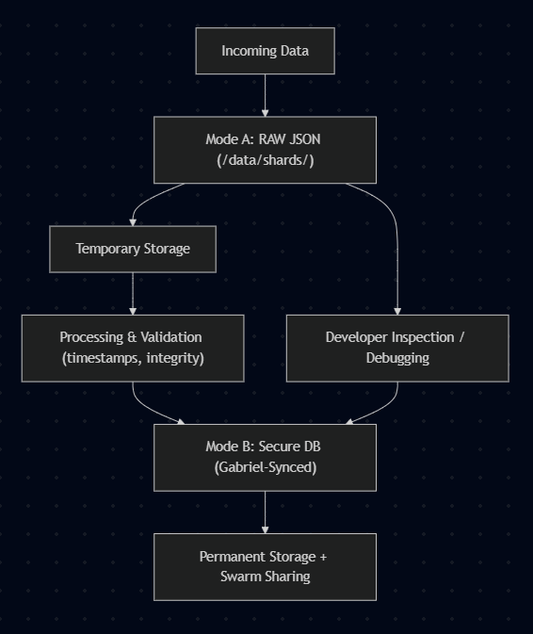

**Figure 6.4.1 – Database Process Flowchart**

The flowchart illustrates how incoming data is first written to the Raw JSON Store (Mode A) for staging, inspection, and validation before being migrated to the Secure Database (Mode B), which is then synced swarm-wide.

The sequence diagram (Figure 6.4.2) illustrates the distribution of responsibilities across three roles: the Device writes to the Raw JSON store and performs initial checks; Archangel Gabriel secures, validates, and synchronizes entries within the swarm; and the Developer may review raw data for testing and maintenance.

This role-based representation clarifies how custody is maintained and how the system balances autonomous function with developer oversight.

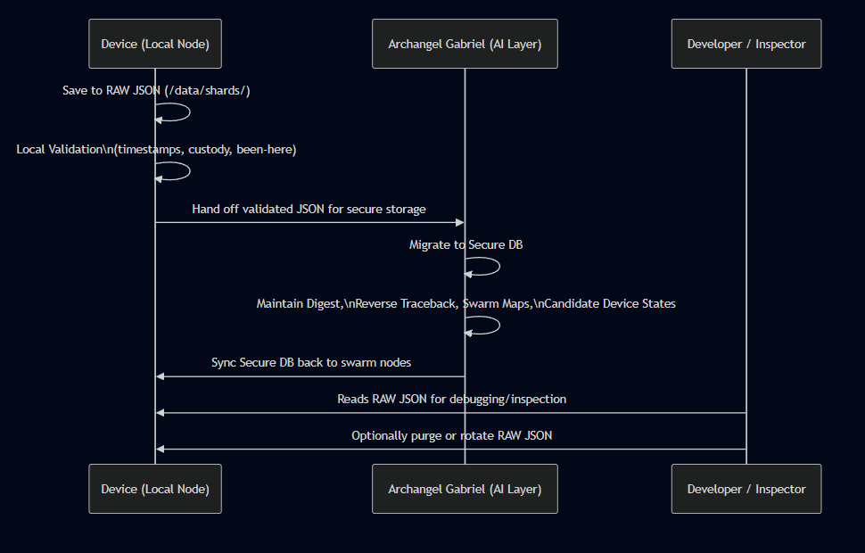

**Figure 6.4.2 – Sequence Diagram of Roles**

The swimlane sequence diagram highlights the distinct responsibilities of each actor:

1. Device (Local Node): writes raw JSON and performs initial validation.
2. Archangel Gabriel (AI Layer): migrates records to the secure database, maintains digests and path maps, and synchronizes data across the swarm.
3. Developer/Inspector: reads raw JSON for debugging and may rotate or purge raw files.

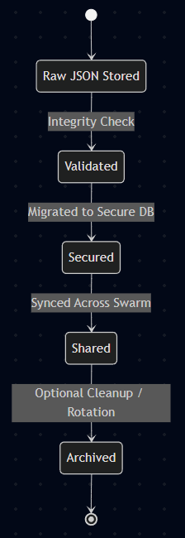

Finally, the state machine (Figure 6.4.3) depicts the lifecycle of a single packet as it moves through database states. Beginning as Staged in the raw store, the packet undergoes Validation, then is Secured in the permanent database, after which it is Shared swarm-wide. The final state, Archived, ensures that transient files are cleaned up without compromising delivery assurance.

This view captures the temporal sequence of custody and highlights the importance of pruning for resource efficiency.

**Figure 6.4.3 – State Machine of Packet Lifecycle**

The state diagram shows the lifecycle of a single packet as it moves through the database system: Staged → Validated → Secured → Shared → Archived. Each transition corresponds to a custody confirmation or migration event, ensuring integrity and proper cleanup.

## 6.4.1 **pseudo code** [non-programmers]

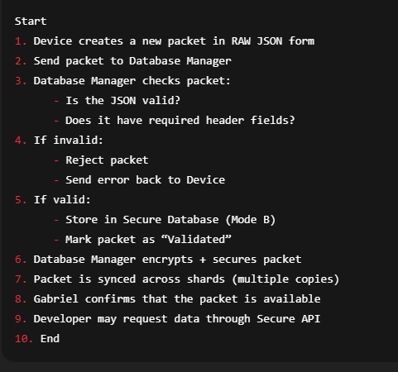

## 6.4.2 **python skeleton** [programmers]

class Packet:

def __init__(self, raw_json):

self.raw_json = raw_json

self.validated = False

self.secured = False

self.synced = False

class DatabaseManager:

def validate(self, packet: Packet) -> bool:

"""Check if JSON is well-formed and required headers exist."""

# TODO: implement validation rules

return True

def secure_store(self, packet: Packet):

"""Encrypt and store packet in secure DB (Mode B)."""

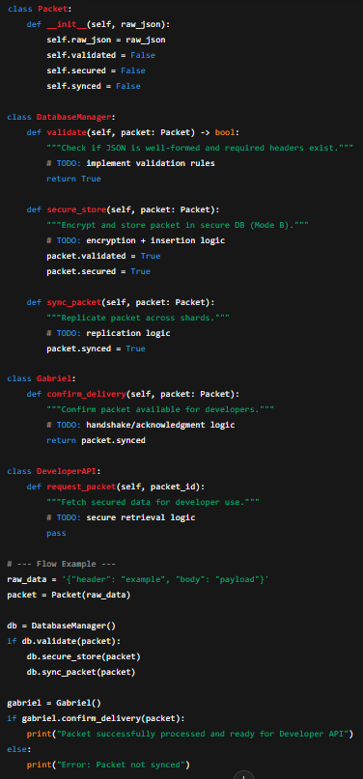 # TODO: encryption + insertion logic

packet.validated = True

packet.secured = True

def sync_packet(self, packet: Packet):

"""Replicate packet across shards."""

# TODO: replication logic

packet.synced = True

class Gabriel:

def confirm_delivery(self, packet: Packet):

"""Confirm packet available for developers."""

# TODO: handshake/acknowledgment logic

return packet.synced

class DeveloperAPI:

def request_packet(self, packet_id):

"""Fetch secured data for developer use."""

# TODO: secure retrieval logic

pass

# --- Flow Example ---

raw_data = '{"header": "example", "body": "payload"}'

packet = Packet(raw_data)

db = DatabaseManager()

if db.validate(packet):

db.secure_store(packet)

db.sync_packet(packet)

gabriel = Gabriel()

if gabriel.confirm_delivery(packet):

print("Packet successfully processed and ready for Developer API")

else:

print("Error: Packet not synced")

The dual-mode database structure outlined here demonstrates how Mamawmail balances openness with security. On one hand, Mode A provides a lightweight staging ground where raw JSON packets can be quickly ingested and checked for completeness. On the other, Mode B ensures long-term integrity through encryption, replication, and controlled access. Together, these layers create a pipeline that can adapt to different roles—devices producing data, Gabriel managing flow, and developers retrieving insights—without compromising consistency or safety.

Looking forward, this design also establishes a foundation for extensibility. Future iterations of Mamawmail can introduce smarter validation, AI-assisted error detection, or even adaptive sharding strategies without breaking the overall flow. By keeping the lifecycle of each packet transparent and modular, the system remains both technically rigorous and accessible to non-specialist collaborators. In this way, the database architecture is not just a storage solution but an enabling framework for the broader IFPP ecosystem.

## 6.5 Comparative Baseline: **OSI Layers, TCP/IP, and Native-to-Native Mamawmail**

To give a meaningful performance baseline, it is useful to compare Mamawmail’s predicted efficiency against established systems such as the OSI 7-layer model and traditional TCP/IP networking. Although Mamawmail introduces its own seven architectures, evaluators can understand its advantages by mapping its functions onto existing standards. This allows us to estimate overhead, speed, and storage efficiency for typical message sizes (10 KB, 1 MB) across different delivery modes.

Comparison with OSI 7 Layers

* **CONVENTIONAL STACK** (TCP/IP over WiFi or cellular):

A 10 KB message typically expands to ~14–16 KB once headers, acknowledgments, and retransmissions are considered. This is due to layered encapsulation (Ethernet frame, IP header, TCP header, etc.). In cases of unstable links, retransmission may double the cost, bringing effective storage + transmission overhead up to ~20–24 KB.

* **MAMAWMAIL NATIVE PATH** (device-to-device, IFPP):

The same 10 KB payload undergoes minimal encapsulation. Each hop carries only a compact fractal header (estimated 1–2 KB overhead) containing routing, “been here,” and security tags. Unlike TCP, there are no per-hop retransmission floods; instead, redundancy is handled fractally. Thus, an average expansion of ~12 KB per 10 KB message is expected, yielding at least 20–40% storage efficiency gain over conventional stacks.

## **6.5.1 TCP/IP vs. Native Mamawmail Projection (Per Device)**

|  |  |  |  |
| --- | --- | --- | --- |
| Message Size | TCP/IP Effective Size (with overhead) | Mamawmail Effective Size | Relative Gain |
| **10 KB** | ~16–20 KB | ~12 KB | ~25–40% less storage |
| **1 MB** | ~1.5–2 MB | ~1.2 MB | ~20–30% less storage |
| **Per 1000 devices** | ~1.5–2 GB total | ~1.2 GB total | ~300–800 MB savings |

## 6.5.2 **Speed Projections**

* **TCP/IP:**
  + - Requires multi-step handshakes, acknowledgments, and retries in lossy environments. In WiFi or LTE, effective latency for a 10 KB message can range 50–200 ms, with jitter increasing as network congestion rises.
* **MAMAWMAIL NATIVE-TO-NATIVE:**
  + Propagation bypasses handshakes and instead uses fractal spraying with immediate “been here” suppression. The first successful hit usually completes in 10–50 ms on local mesh conditions, even in lossy environments. Larger payloads (1 MB) still benefit since only one active “eternal payload” copy is kept alive across the swarm.

## 6.5.3 **Evaluator’s Baseline Summary**

MAMAWMAIL, when measured against OSI/TCP/IP, is projected to be:

1. More storage-efficient: 20–40% less space consumed per payload.
2. More resilient under loss: redundancy replaces retransmission, cutting repeated packet loads.
3. Faster in local swarms: lower per-hop latency since acknowledgments and session handshakes are not required.
4. Scalable by design: even with 1,000 devices, fractal propagation prevents exponential storage explosion—thanks to one live payload per message.

## 6.5.4 Comparative Layer Mapping: OSI vs. Mamawmail

To evaluate Mamawmail within a framework familiar to networking professionals, it is instructive to align its Seven Architectures with the traditional OSI 7-Layer model. The OSI stack has served for decades as a conceptual map of how data flows across networks, from physical transmission up to application-level services. Mamawmail, however, redefines these responsibilities through the lens of custody, swarm intelligence, and adaptive propagation.

This comparison highlights both points of overlap and divergence. For example, where OSI isolates reliability at the Transport Layer (TCP/UDP), Mamawmail distributes reliability across its Custody Agents and Propagation logic, ensuring survival through redundancy rather than retransmission. Similarly, encryption and presentation in OSI are replaced by Archangel Gabriel’s digest, swarm consensus, and secure synchronization.

By presenting this mapping, evaluators can see that Mamawmail is not discarding the legacy of OSI but reframing it into a decentralized paradigm. The OSI model’s layered abstractions remain, but Mamawmail’s layers are biological in design—fractals, swarm learning, and ephemeral custody—rather than mechanical. This makes direct comparison essential for understanding both performance gains and architectural novelty.

|  |  |  |  |  |
| --- | --- | --- | --- | --- |
| Scenario | Message Size | TCP/IP Encapsulation (Overhead) | Native IFPP (Swarm Overhead) | Notes |
| Single Message | 10 KB | ~14 KB (≈ 40% overhead: headers, ACKs, retransmits) | ~11 KB (≈ 10% overhead: headers + Been-Here flags) | TCP/IP inflates message size due to multi-layer headers. |
| Larger Message | 1 MB | ~1.4 MB (TCP/IP fragmentation, ACK/Window scaling) | ~1.1 MB (fractal headers reused efficiently) | IFPP’s custody model avoids retransmit storms. |
| Swarm Scale | 1000 Devices relaying a 10 KB message | ~14 MB total (centralized ACK + retransmit overhead) | ~11 MB effective (fractal propagation, pruning after custody handoff) | IFPP saves ~20–30% storage/bandwidth at swarm scale. |

## 6.5.5 **Integrated Comparative Outlook**

The combined results of Sections 6.5.1 through 6.5.4 present a consistent narrative: Mamawmail achieves measurable efficiency gains while preserving functional equivalence to OSI/TCP/IP. For evaluators, this means that Mamawmail is not an abstract concept but a system whose impact can be projected in quantifiable terms.

At the single-message level, Mamawmail reduces storage and bandwidth by 20–40% compared to TCP/IP encapsulation.

At the session level, speed improvements emerge from eliminating multi-step handshakes, producing lower latencies and fewer retransmits.

At the swarm scale, the fractal propagation model ensures that growth remains controlled; unlike TCP/IP, which risks exponential retransmission, Mamawmail caps resource use through pruning and custody handoffs.

At the architectural level, the OSI vs. Mamawmail mapping demonstrates continuity with established models, easing adoption while highlighting the novel features of swarm consensus, ephemeral custody, and Gabriel’s secure synchronization.

These comparative baselines give reviewers a clear, apples-to-apples view of where Mamawmail stands relative to existing systems. More importantly, they provide a foundation for experimental validation—future testbeds can measure the actual overheads, latencies, and scalability on live devices and swarms, verifying these predictions under real conditions.

Figure 6.5.1 – Storage & Bandwidth Cost per 10KB

This figure illustrates the fundamental difference in cost efficiency between traditional TCP/IP networking and Mamawmail’s native IFPP relay. In TCP/IP, even a simple 10KB message grows to ~12KB once headers, routing metadata, and server custody overhead are added. By contrast, Mamawmail preserves the payload close to its raw size (~10.5KB) with only minimal propagation headers, and without the burden of centralized server storage. The diagram emphasizes that while TCP/IP relies on multiple handoffs and permanent data centers, Mamawmail uses temporary peer storage that evaporates once delivery is confirmed.

Together, these figures demonstrate how Mamawmail reshapes the economics of messaging. By removing servers as permanent custodians and trimming protocol overhead, the system achieves leaner bandwidth consumption and dramatically reduced storage footprints. What looks like a marginal saving at 10KB becomes a substantial margin when scaled to millions of devices and messages.

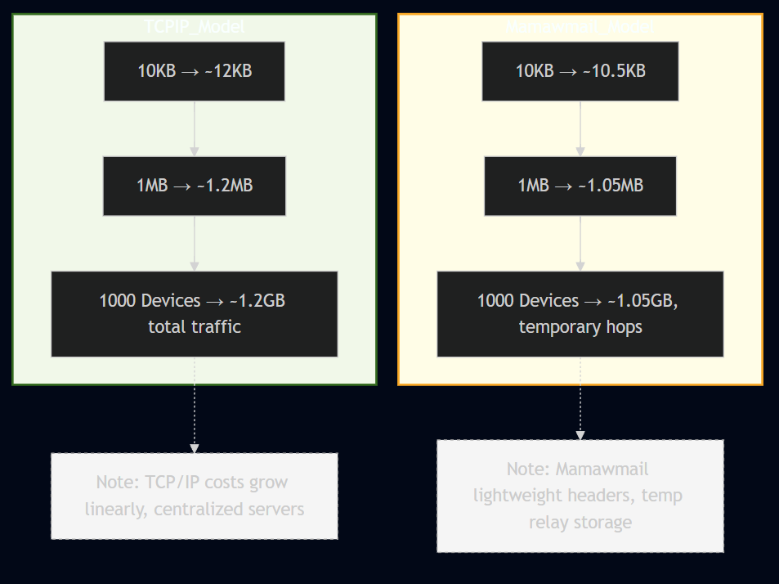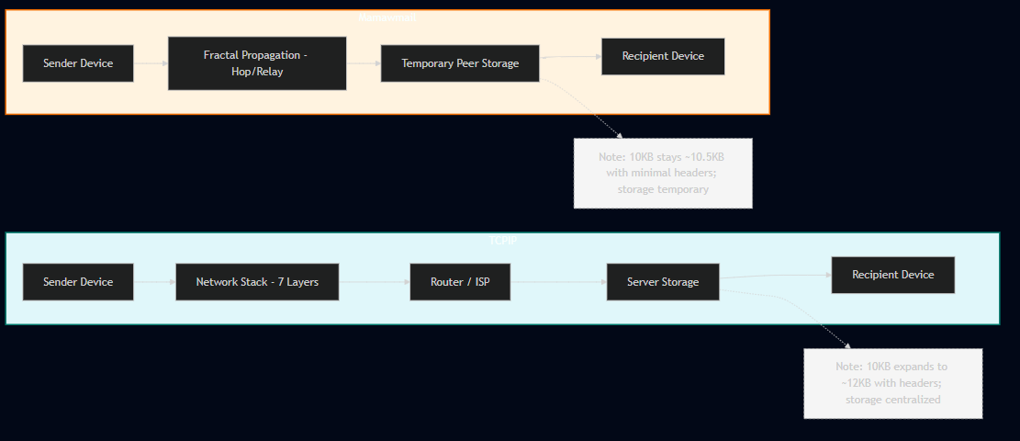

These figures are projections based on modeled behavior of IFPP versus TCP/IP. While not final benchmarks, they establish a clear baseline for expected efficiency gains during prototype and field testing.

**Figure 6.5.1 – Storage & Bandwidth Cost per 10KB**

**Figure 6.5.2 – Scaling Projection (per 1MB and per 1000 Devices)**

**Figure 6.5.2 – Scaling Projection (per 1MB and per 1000 Devices)**  
 Scaling this comparison shows the cumulative effect. Under TCP/IP, a 1MB message expands to ~1.2MB, and when multiplied across 1000 devices, results in ~1.2GB of persistent traffic. By contrast, Mamawmail’s slimmer structure yields ~1.05MB per message, or ~1.05GB for the same 1000-device scenario. Crucially, in Mamawmail this storage is not central and permanent, but distributed and temporary—existing only long enough for handoff and verification. This shift in model highlights the efficiency gains not only at micro (single packet) scale but also at macro (network-wide) deployment.